A MICROSIMULATION COMPARISON FOR LANE-MERGING DRIVER BEHAVIORS

Tianxin Shen, Mary L. Cummings

While driving behaviors have been widely studied with various microscopic simulations, comparatively little attention is paid to how different microscopic simulation environments measure the same human driving behaviors. To this end, we compared aggregate human driving behaviors for two microscopic simulators, SUMO and PTV Vissim, in zipper and early merge scenarios. We used standard embedded driver and traffic models for both microscopic simulators. Results showed the two simulators were generally equivalent in computational resource demand but produced delay estimates that were not consistent with one another, or internally. Another finding is that SUMO produced more variability than PTV Vissim, which may be an advantage when representing human behavior uncertainty that is highly variable. Ultimately, the choice of simulation environment depends on the research question, monetary costs, and human costs of development.

Introduction
Microscopic simulation software programs are widely used to evaluate the influence of human driving behavior, vehicle technologies and infrastructure on traffic flow and related outcomes. The quality and interpretability of the results are directly linked to the ability of such a simulation environment to reflect accurate vehicle, driver and environment models.
PTV Vissim is commercial off-the-shelf, widely-used traffic simulation software for businesses and industries (Vissim, 2010). Various researchers (e.g., Fellendorf, 2010; Fellendorf, 2001; Weyland, 2019) have shown that it can generally capture vehicle, behavior and environment variables of interest. Its ability to cope with large traffic networks fits well with urban traffic planning (Ejercito, 2017). However, it can be expensive and the scripting to change in-built characteristics can be high in workload.
SUMO is an open source, highly portable and continuous multi-modal traffic simulation package (SUMO, 2022). Different from PTV Vissim, the source code of SUMO can be directly downloaded, and programmers can modify it based on their needs. It allows for diverse applications and satisfies specific requirements. Due to the openness of SUMO, it requires significant effort to generate route files and map generalized net files (Ejercito, 2017).
The main differences for SUMO and PTV Vissim in terms of vehicular and driving behaviors primarily lie in the car-following models and lane-changing models. SUMO utilizes the Krauss car-following model, which falls into the category of safety-distance models, where a vehicle's velocity is adjusted to keep a safe distance to the front vehicle (Pouradbollah, 2017).
PTV Vissim utilizes the Wiedemann car-following model, belonging to the psycho-physical car-following model category, where the vehicle velocity depends on perceptive thresholds such as the minimum velocity difference between follower and leader (Pouradbollah, 2017). Although many studies have compared the two car-following models, there are very few studies that look at the aggregate performance across scenarios with different driving behaviors.
Comparative studies (Ejercito, 2017; Maciejewski, 2010; Saidallah, 2016) have illustrated the general feature differences for commonly-used microscopic simulation software. However, there is little discussion and explanation about how these differences may affect results and conclusions, particularly where human behavior is involved. In order to determine how and why these two popular microsimulation environments differed and influenced results, we conducted experiments with this two common microscopic simulation software (SUMO and PTV Vissim) in two different lane-merging settings.

Method
The merging scenario was selected as the representative test case to compare SUMO and PTV Vissim since the results are directly linked to driver behaviors. We focused on two merge scenarios commonly seen in daily life, the zipper and early merge scenarios. Zipper merge occurs when vehicles stay in their lanes until reaching the defined merge point and alternate in "zipper" fashion into the open lane (MnDot, 2022). Early merge, also known as the priority merge, occurs when traffic in the soon-to-be-closed initiates movement into the open lane earlier in advance of the lane closure point (FHWA, 2022).
To this end, we designed a typical two-lane merge map, (Fig. 1). The total length of lanes is 450 m, with 400 m before the merge point and 50 m after the merge point. The driver’s behavior parameters were selected to represent typical drivers in both microscopic simulations and included car minimum gap, car maximum deceleration, and driver cooperativeness.
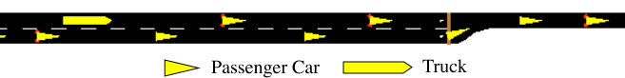
Figure 1. Two-Lane Merge Map in SUMO.
In order to explore the impact of congestion on merging behaviors, the experiments included two levels of input volumes, a low volume of 4000 input cars, and a higher volume of 6000 input cars. Then, different outputs for the key simulation indices were generated and analyzed based on the eight scenarios in Table 1.
Table 1. Experiment Scenarios Summary Table.
Scenario | Volume | Merge Type | Software
1 | Low | Zipper | SUMO
2 | High | Zipper | SUMO
3 | Low | Early | SUMO
4 | High | Early | SUMO
5 | Low | Zipper | PTV Vissim
6 | High | Zipper | PTV Vissim
7 | Low | Early | PTV Vissim
8 | High | Early | PTV Vissim

The vehicle composition for all scenarios is shown in Table 2 and the details for input car volumes for low and high traffic volume are listed in Tables 3 and 4. Randomly selecting simulation seeds, 30 simulation runs were conducted for each scenario in Table 1, with the input period of 9000s and intervals set to 900s.
Because the level of experimenter control in SUMO and PTV Vissim are not equivalent, as well as the dissimilar car-following models, we focused on maintaining equivalent car flow rates and the detailed parameters are shown in Table 5. In order to minimize the effect of the increasing flow rate at the beginning of each simulation run, all measures were collected after a 5-minute warm-up period and stopped when all input vehicles reached the destination.

Table 2. Microsimulation Vehicle Inputs.
Vehicle Type | Percentage | Speed (km/h)
Passenger Car | 85% | 50
Heavy-loaded vehicles (Truck) | 15% | 30

Table 3. Input Car Volume for Low Traffic Volume Scenarios.
Start Time (minute) | End Time (minute) | Input Vehicles Number
0 | 15 | 875
15 | 40 | 1000
30 | 45 | 1125
45 | 150 | 1000
Total (150 minutes) |  | 4000

Table 4. Input Car Volume for High Traffic Volume Scenarios.
Start Time (minute) | End Time (minute) | Input Vehicles Number
0 | 15 | 1312
15 | 40 | 1500
30 | 45 | 1688
45 | 150 | 1500
Total (150 minutes) |  | 6000

For the zipper merge, cars did not initiate a lane change until they reached the merge point. All vehicles waited at the end of the lane in a queue if no space was immediately available. For the early merge scenarios, cars would merge as soon as they found a suitable gap in traffic, but were required to finish merging 50m before the merge point. Other than the difference in merge settings, all vehicle and driver behavior parameters were kept the same across all scenarios.
Table 5. Parameter Settings for SUMO and PTV VISSIM.
Common Parameters
Car minimum gap | 1.5 m
Acceleration | 2.6 m/s
Deceleration | 4.5 m/s
SUMO
Car length | 5
Depart speed | default
Sigma | 0.5
Tau | 1
lcCooporative | 0.6
PTV Vissim
Car length | default
Depart speed | default
Safety distance reduction factor | 0.6
Maximum deceleration for cooperative braking | -3 m/s
Look ahead distance | 2

The metrics used to compare the two microsimulation environments and different scenarios included average queue delay time and overall simulation time, per simulation run. The definition for queue delay is the additional travel time per individual vehicle caused by a queue resulting from congestion. A queue occurred when a car’s speed was less than 5 km/h and ended when speed was greater than 10 km/h. Simulation time is the total time taken by the software to finish one simulation run.

Results
Thirty simulation runs for each software program for each of the lane merging scenarios in Table 1 were conducted on a Dell precision 5530 mobile workstation to observe the performance of SUMO and PTV Vissim. Tables 6-9 summarize average queue delays and simulation times for the two different microscopic simulators in low and high traffic volume scenarios. Figure 2 illustrates the boxplots for the eight different scenarios as outlined in Table 1 for the queuing delay experienced, on average.

Table 6. Low Volume Scenarios Queue Delays
Parameter | Queue Delay (seconds/car)
Merge Type | Early |  | Zipper
Software | PTV Vissim | SUMO | PTV Vissim | SUMO
Mean | 10.96 | 21.63 | 11.81 | 33.73
Std | 0.83 | 3.62 | 0.72 | 17.23
Min | 9.24 | 29.00 | 10.45 | 77.00
Max | 12.93 | 15.00 | 13.12 | 13.00

Table 7. Low Volume Scenarios Simulation Times
Parameter |  | Simulation Time (seconds)
Merge Type |  | Early |  | Zipper
Software |  | PTV Vissim | SUMO | PTV Vissim | SUMO
Mean |  | 9047.33 | 9055.57 | 9049.06 | 9069.10
Std |  | 14.65 | 1.19 | 11.08 | 49.80
Min |  | 9081.73 | 9059.00 | 9079.89 | 9314.00
Max |  | 9027.78 | 9054.00 | 9029.04 | 9053.00

Table 8. High Volume Scenario Queue Delay
Parameter | Queue Delay (seconds/car)
Merge Type | Early |  | Zipper
Software | Vissim | SUMO | Vissim | SUMO
Mean | 69.69 | 29.03 | 85.51 | 68.83
Std | 1.00 | 4.19 | 1.07 | 9.07
Min | 67.99 | 37.00 | 83.39 | 83.00
Max | 71.51 | 22.00 | 87.94 | 46.00

Table 9. High Volume Scenarios Simulation Times
Parameter |  | Simulation Time (seconds)2
Merge Type |  | Early |  | Zipper
Software |  | Vissim | SUMO | Vissim | SUMO
Mean |  | 11641.99 | 13040.47 | 11640.64 | 13201.63
Std |  | 33.99 | 18.58 | 33.77 | 97.87
Min |  | 11694.00 | 13069.00 | 11694.00 | 13382.00
Max |  | 11566.78 | 12988.00 | 11566.78 | 13016.00

Due to the non-linearity of data, non-parametric Mann-Whitney U tests were used for statistical comparisons. All pairwise differences between microscopic simulators were significant in Fig. 2 (p <0.001), save for the comparison between the early and zipper merge scenarios under the low volume condition (p = .025, alpha = .0125). It is also noteworthy that PTV Vissim estimates were lower than SUMO’s under the low traffic volumes but greater under the higher traffic volumes (Fig. 2).
Figure 3 illustrates the length of time both simulations took to run for the low and high scenarios. For statistical comparison, the data were weighted by the numbers of cars pushed through the simulations in Tables 3 and 4. Using a Mann Whitney U test, there was expectedly a difference between the low and high volume scenarios (p < .001), and between the zipper and early merge scenarios (p < .001). However, there was no difference between Vissim and SUMO programs (p = .877).

Discussion
These results raise several important considerations regarding using SUMO and PTV Vissim in simulating driving behavior. From a computational demand perspective, the two programs performed similarly as seen in Fig. 3. While there were differences in run times for different volumes and merging scenarios, this is expected given the different behaviors and numbers of vehicles per scenario. When compared directly, the SUMO and Vissim run times were not different, suggesting that choosing either simulation environment would not substantially impact computational resources.

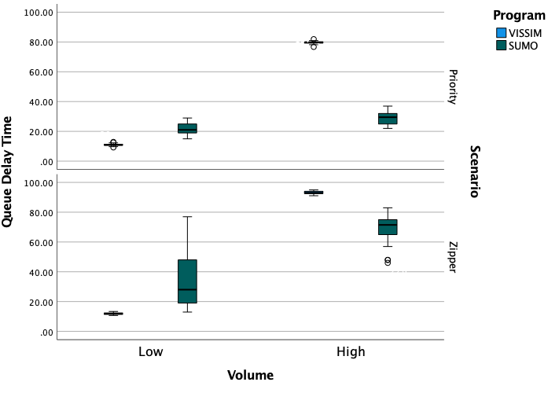
Figure 2. Queue Delay Times for the Scenarios in Table 1.
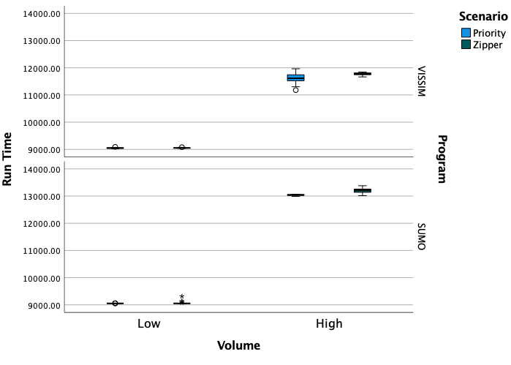
Figure 3. Simulation run times for the Scenarios in Table 1.
While there appeared to be no critical differences in computational resource demand between the SUMO and PTV Vissim, there was an important difference in examining the delay times between the two simulation environments. Comparisons between the two simulations statistically differed except for the difference between the early and zipper merge scenarios for low volumes (Fig. 2). Moreover, the differences were not consistent, in that under low volumes PTV Vissim produced lower delay estimates than SUMO, but this trend was reversed under high traffic volumes. Such a lack of consistency means that without ground truth, it is hard to know if and which simulation is correct.
For example, the transportation industry generally agrees that the zipper merge is more efficient than the early merge (McCoy, 2001; Wolshon, 2012), but these results indicate that using one simulation environment to estimate such delays could provide different outcomes than observed data. While this study used a generic merging environment to make direct comparisons, these results provide further evidence for the importance of validating simulations with real-world data to ensure the results mirror actual environments.
In addition, it is not clear what potential negative effects were caused by individual parameter selection in the simulation models. For example, in SUMO, there is a parameter representing drivers’ behavior: lcCooporative, which controls whether the cars are cooperative. This was set at 0.6 to maintain a comparable car flow rate with PTV Vissim in this study, but the results could be very different with a different setting.
For all PTV Vissim simulation runs conducted in Table 1, the driver behavior parameters were set to default values according to Ahmed (2021), which validated the default lane-changing parameters represent the normal drivers. While we made every attempt to make the two programs as similar as possible, many settings are not transparent, and users must accept the range of values and variables provided.
The last important difference is the degree of variability in the two different environments. Tables 5 and 6 and Fig. 2 show that SUMO contained much more variability in results as compared to VISSIM. While it is common for discrete event simulations to have low variation in such results (Altiok, 2010), for simulations attempting to capture variability associated with human behavior, it may be preferable to use the simulation that generates a larger range of values, including more extreme values. While transportation professionals may prefer point estimates for different aspects of traffic planning, as traffic systems incorporate more complex technologies, it is likely that understanding the range of outcomes, particularly for human behavior, will be as, if not more, important than understanding point estimates.

Conclusion
In this effort, we compared two microscopic simulators, SUMO and PTV Vissim, in their ability to predict delay times for drivers executing two different traffic merging scenarios under low and high volumes of traffic. Results showed that the two environments were equivalent in computational resource demand but produced delay estimates that were not consistent either with one another, or internally. Moreover, SUMO produced results with more variability.
This study does not indicate that either environment is superior overall, but there are many advantages and disadvantages to both programs. From a performance perspective, PTV Vissim effectively provided point estimates which may not be preferable in some scenarios where the research goal is to determine the limits of human behavior on an overall system’s performance. When assessed by other qualitative metrics, PTV Vissim is proprietary, with many opaque settings and carries licensing costs. SUMO is open source but contains less documentation and user support than PTV Vissim. Ultimately which simulation environment is best should be determined by the research question, as well as monetary costs and human costs of development.

Acknowledgments
This research was sponsored by the North Carolina Department of Transportation Center of Excellence for Smart Connected and Automated Vehicle Fleet Management, under the direction of the NC State University Institute for Transportation Research and Education. Tanmay Das and Nagui Rouphail provided critical feedback.

References
Ahmed, H. U., Huang, Y., & Lu, P. (2021). A review of car-following models and modeling tools for human and autonomous-ready driving behaviors in micro-simulation. Smart Cities 4(1), 314-335.
Altiok, T., & Melamed, B. (2010). Simulation modeling and analysis with Arena. Elsevier.
Ejercito, P. M., Nebrija, K. G. E., Feria, R. P., & Lara-Figueroa, L. L. (2017). Traffic simulation software review. 2017 8th International Conference on Information, Intelligence, Systems & Applications (IISA), Cyprus, 1-4.
Fellendorf, M. & Vortisch, P. (2010). Microscopic traffic flow simulator VISSIM. Fundamentals of Traffic Simulation-International Series in Operations Research & Management Science, 145, 63-93.
Fellendorf, M. & Vortisch, P. (2001). Validation of the microscopic traffic flow model VISSIM in different real-world situations, Transportation Research Board 80th Annual Meeting, 11.
FHWA, F. H. (2022, 14 Feb.). Dynamic Late Merge Control Concept for Work Zones on Rural Freeways from https://ops.fhwa.dot.gov/wz/workshops/accessible/mccoy.htm.
Maciejewski, M. (2010). A comparison of microscopic traffic flow simulation systems for an urban area. Transport Problems, 5, 27-38.
McCoy, P. T., & Pesti, G. (2001). Dynamic Late Merge–Control Concept for Work Zones on Rural Interstate Highways. Transportation Research Record, 1745(1), 20-26.
MnDot, M. D. (2022, 14 Feb.). Zipper Merge - MnDOT. Retrieved from https://www.dot.state.mn.us/zippermerge/
Pourabdollah, M., Bjärkvik, E., Fürer, F., Lindenberg, B., & Burgdorf, K. (2017). Calibration and evaluation of car following models using real-world driving data. 2017 IEEE 20th International conference on Intelligent Transportation Systems (ITSC), 1-6.
Saidallah, M., El Fergougui, A., & Elalaoui, A. E. (2016). A comparative study of urban road traffic simulators. MATEC Web of Conferences, 81, p. 05002.
SUMO. (2022, 14 Feb.). SUMO User Documentation. Retrieved from https://sumo.dlr.de/docs/index.html
Vissim, P. (2010). 5.30 User Manual. PTV Planung TransportVerkehr AG.
Weyland, C. M., Buck, H. S., & Vortisch, P. (2019). The Potential for Traffic Emission Reduction on Freeways with Dynamic Line Control System analyzed with PTV Vissim. 2019 6th International Conference on Models and Technologies for Intelligent Transportation Systems (MT-ITS), 1-9.
Wolshon, B., Ishak, S., & Idewu, W. (2012). Design of Lane Merges at Rural Freeway Construction Work Zones (No. FHWA/LA. 11/484). Louisiana Dept. of Transportation and Development.

